Saturday, April 2
at Albuquerque’s Wheels Museum
multiple award winning singer/songwriter
Doug Figgs (and Badger)
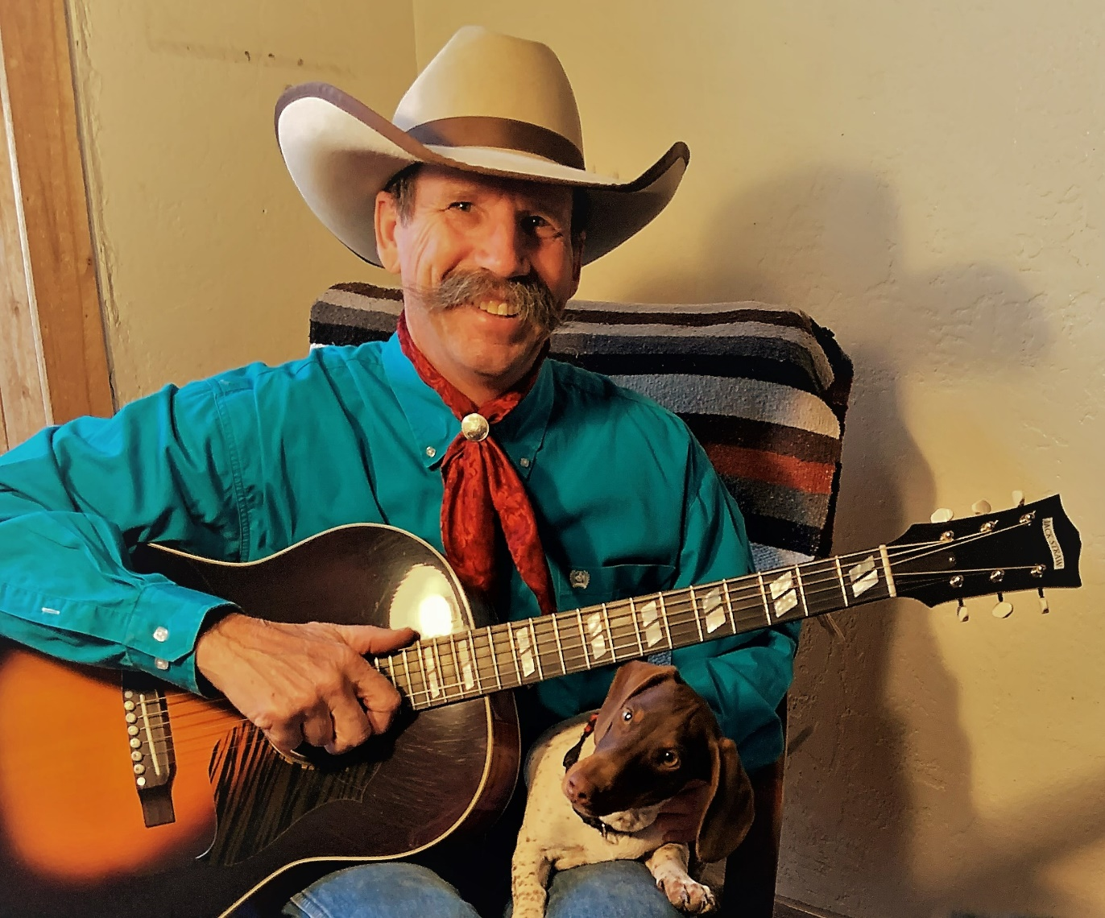
International Western Music Association’s
2021 Male performer of the Year
Along with many other songwriting and performance
awards including two “Wrangler Awards”
Starting 1:00 pm
at Wheels Museum
Tickets $10 each, limited seating
Please RSVP to Leba or Janet 505-243-6269
1100 2nd Street SW Albuquerque, NM

